**Python 1 Semester 1 Final Project**

**Flappy Block**

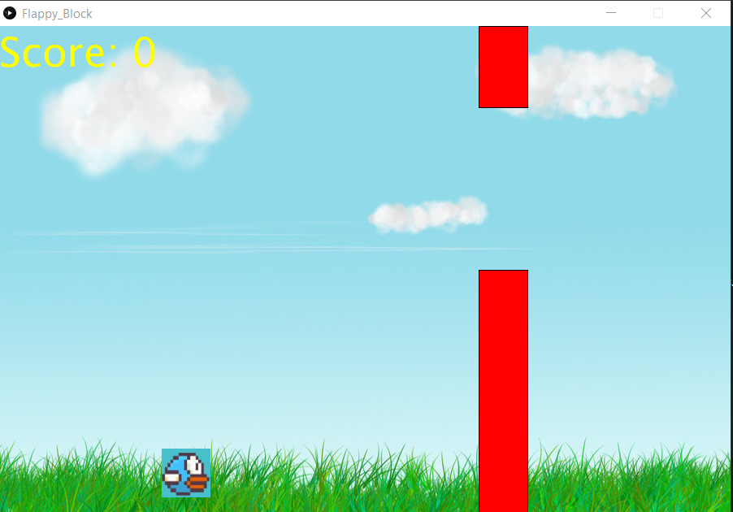For this project you will have to create a replica of the once popular mobile game, “Flappy Bird”. The visuals and sounds are all provided to you already, so you only have to worry about coding. The goal of the game is to guide the bird through as many of the walls as possible. Passing through one wall grants you one point. If the bird hits the ground, the wall or flies up too high then it is game over.

There are two options when it comes to completing the project. You may either type all the code from scratch or take and complete a given partial solution. The partial solution can be found in DropBox.

For the project you will need to understand loops, variables, if-statements, drawing rectangles, drawing text, displaying pictures, animations, global and playing sounds. You should be comfortable with figuring out how to play multiple sounds using the Minim library.

Bonus Components

If you complete the project early the following is a list of things you can add to the game to make it more interesting.

1. Add a sound effect for when the bird dies
2. Make the walls flash and change colors
3. Add a timer to see how long the bird has survived
4. Add a main menu that appears before the game starts

Do **NOT** attempt these bonus components unless you have the core game completed!

Remember to **SAVE YOUR WORK**. You will be presenting this.